Лабораторная работа №1.
OC: Windows 10.
Проверяем версию с помощью команды
docker --version
Появится следующее:
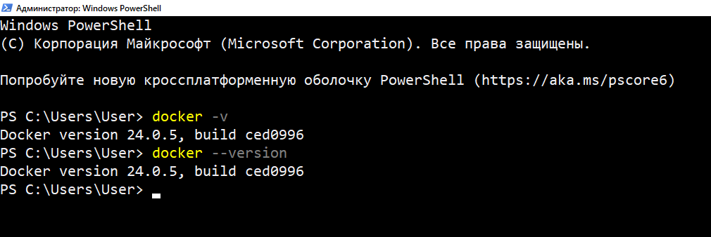
И еще одной команды
docker version
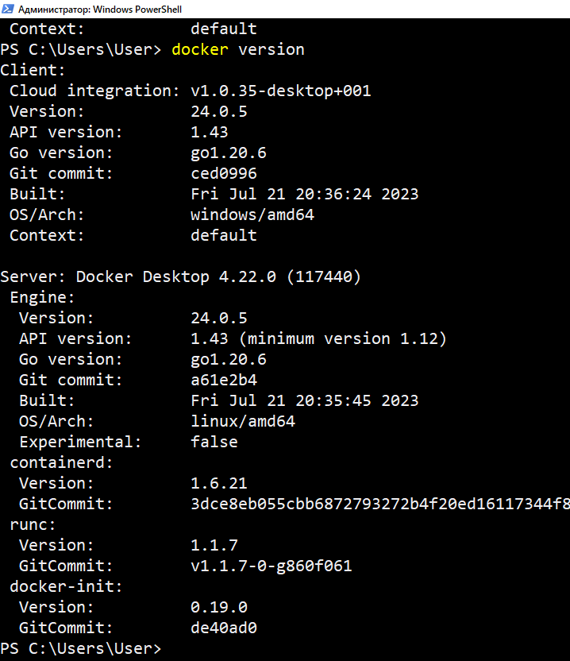

Версии и теги проверяются следующим образом:
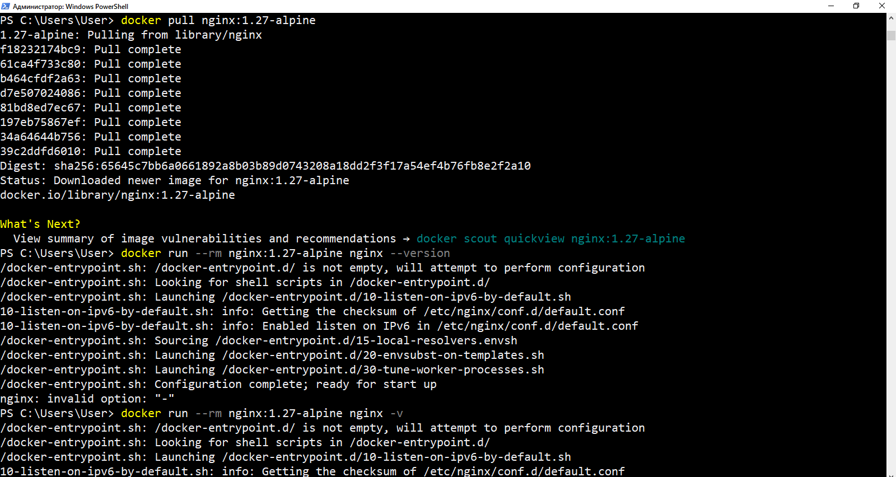
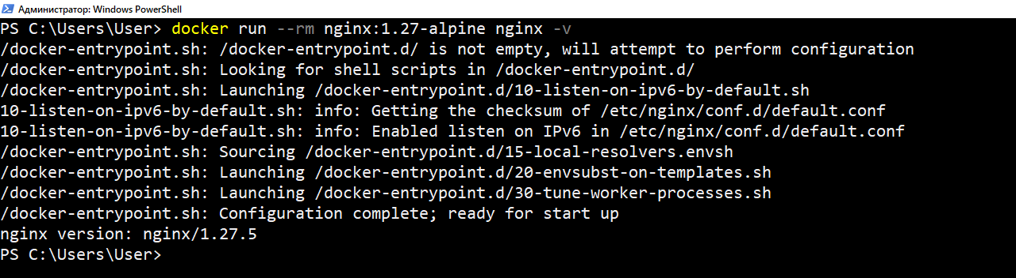
Запускаем
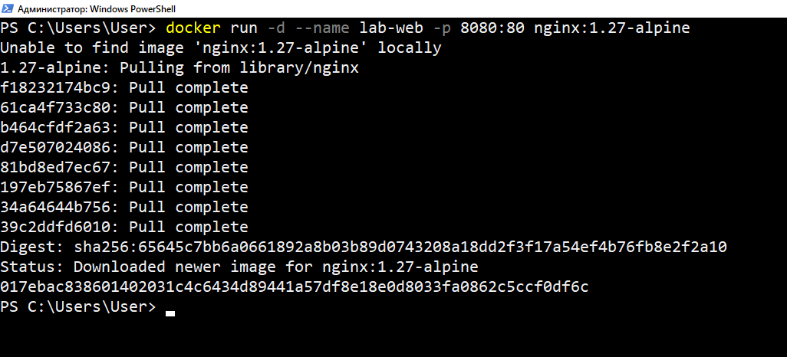

И запускаем
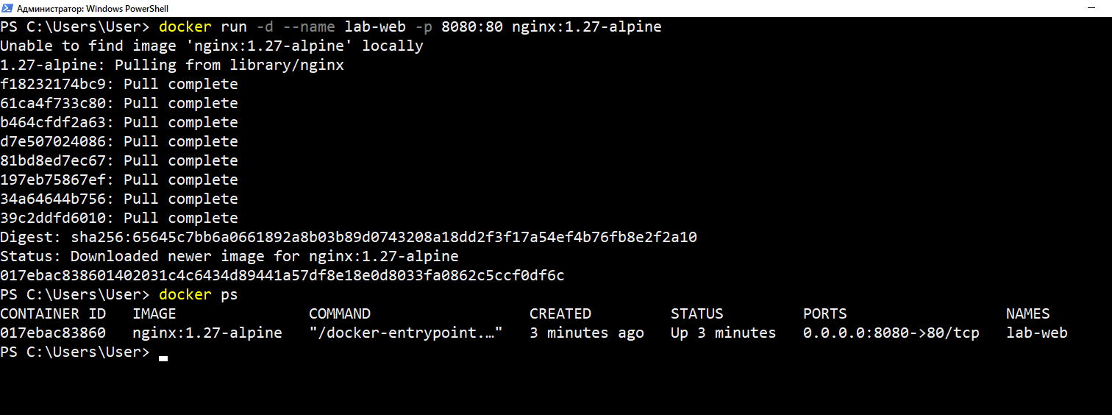
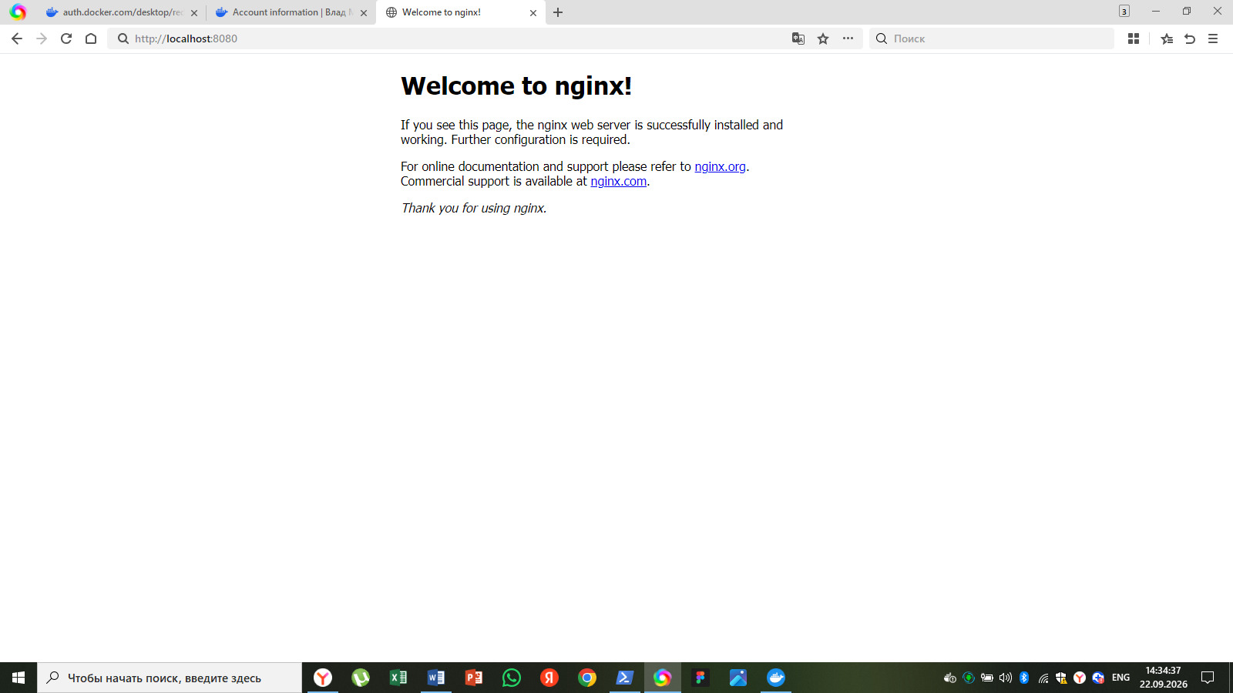
На порте 8081:
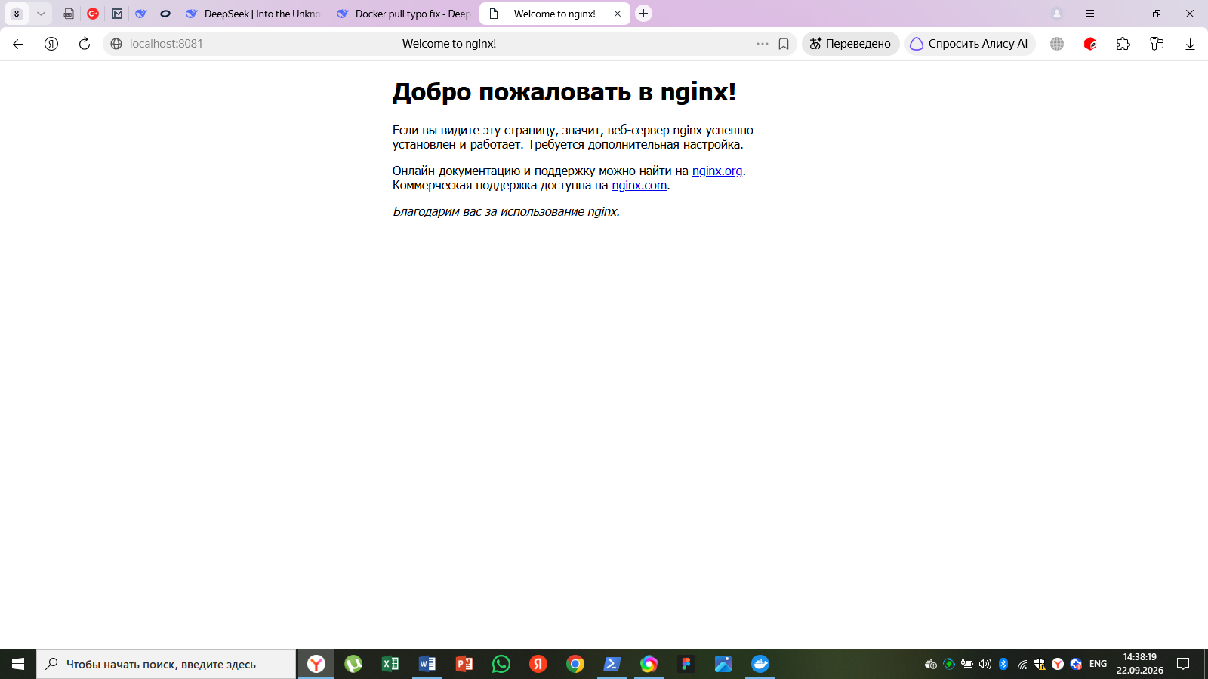
Запуск данных из папки хоста
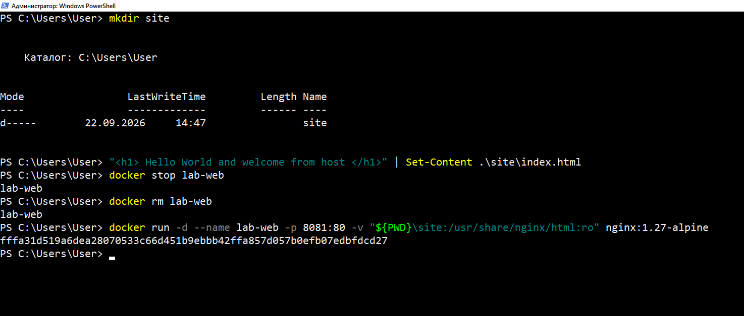

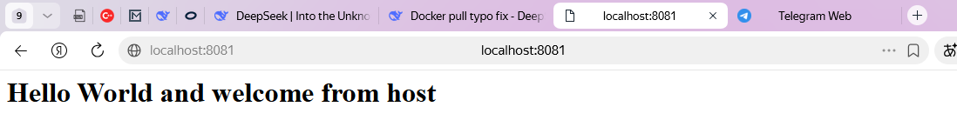
Попробуем обновить файл
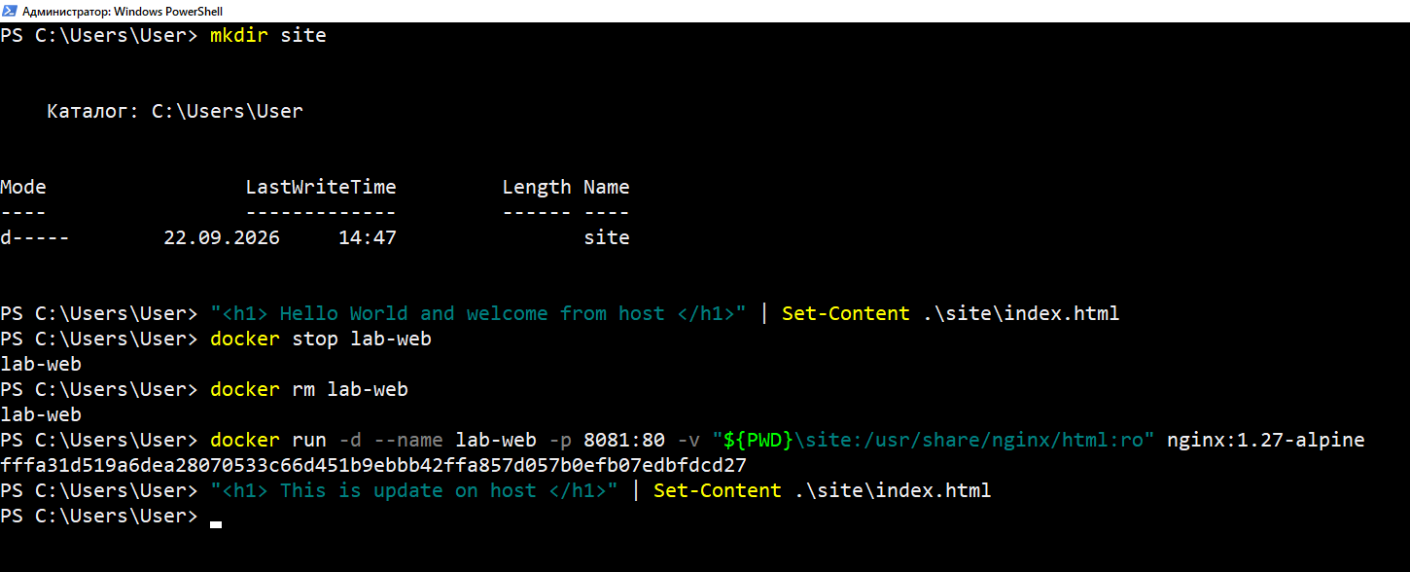
Увидим следующее:
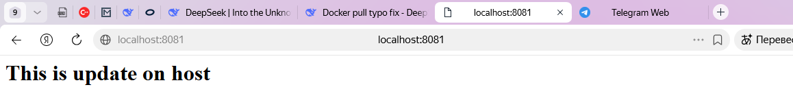

Exec
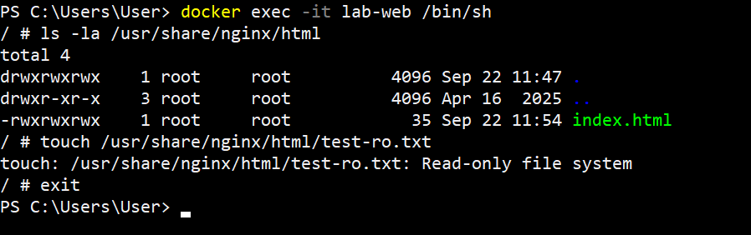
Здесь входим внутрь работающего контейнера, пытаемся создать файл при :ro:
touch /usr/share/nginx/html/test-ro.txt
Ожидаемая ошибка - Read-only file system
Далее перезапускаем контейнер без read-only:
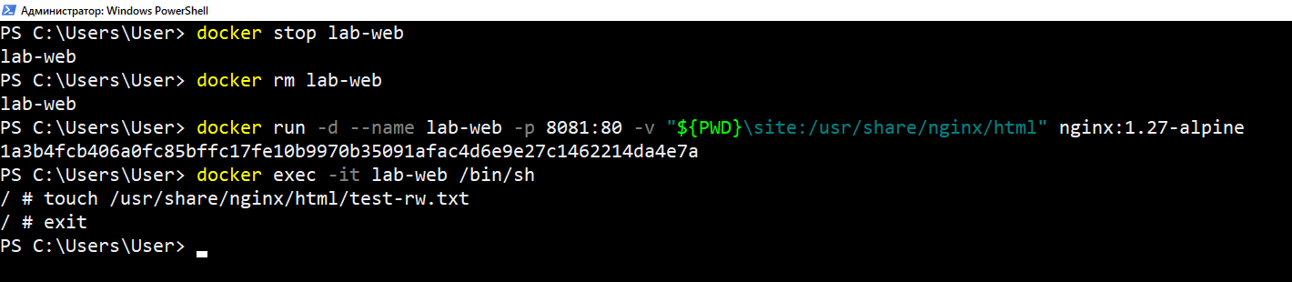
Файл создать получилось, поэтому выходим через exit
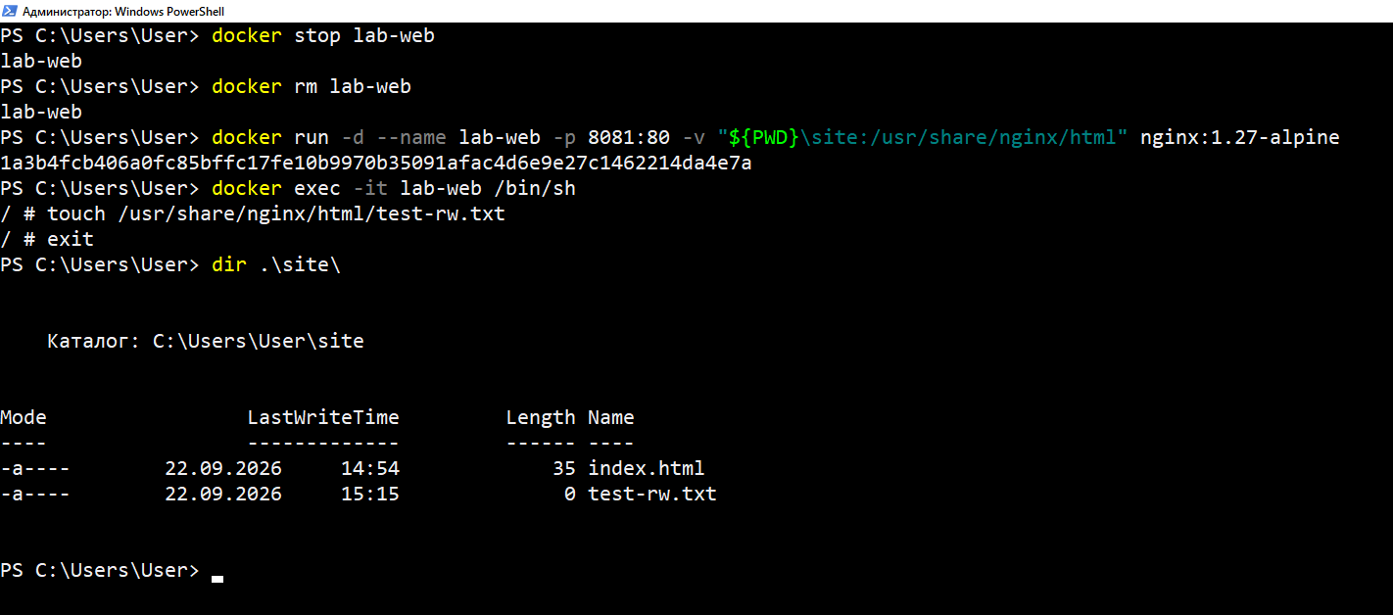

Логи
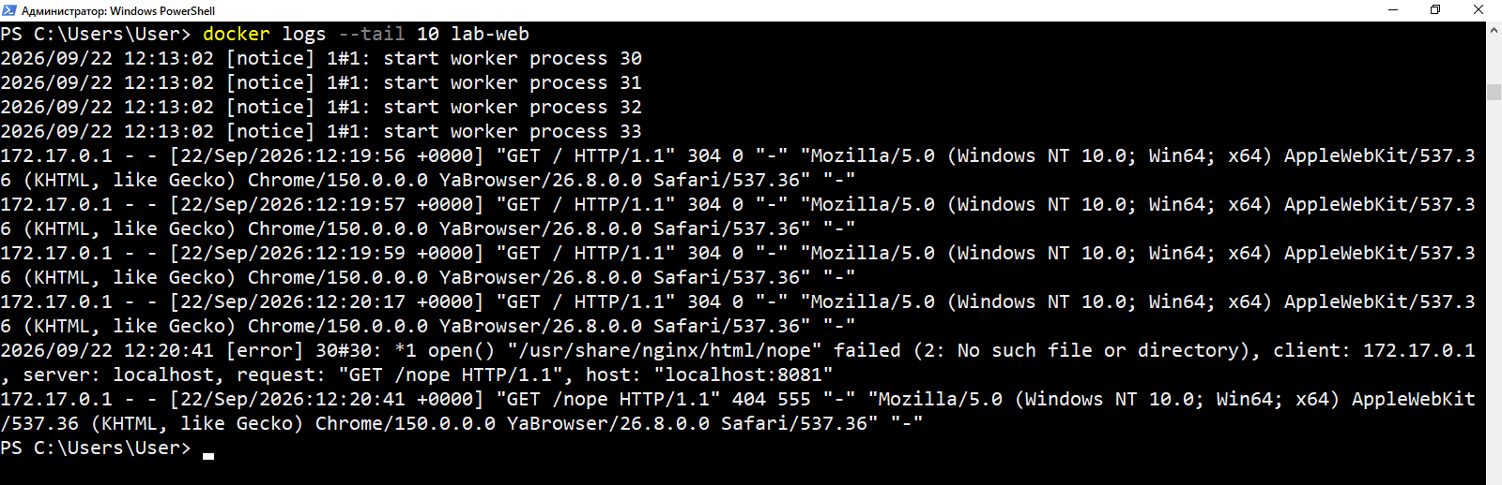
Ctrl+P и Ctrl+Q перестали работать, поэтому attach я завершил вместе с работой контейнера :)
(извините пж)
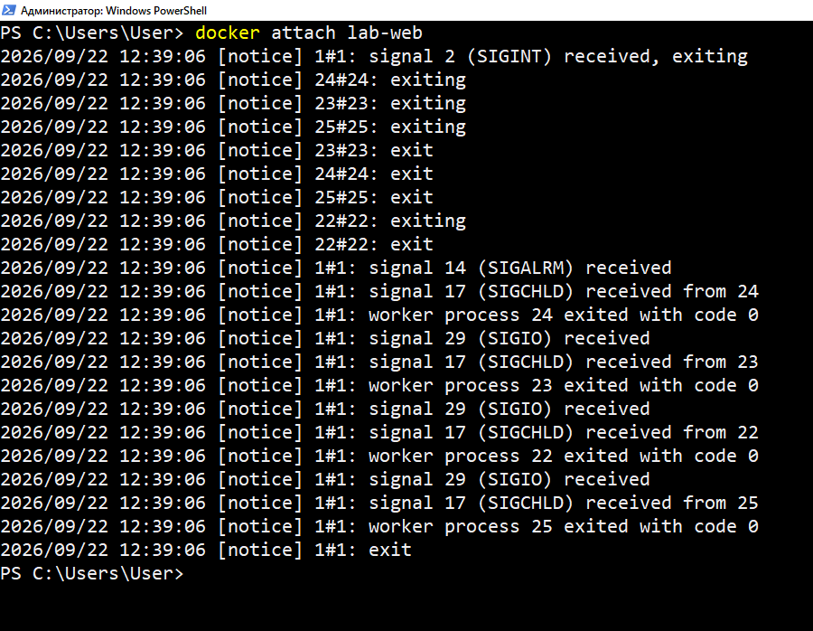

PS C:\Users\User> docker inspect lab-web
[
{
"Id": "1a3b4fcb406a0fc85bffc17fe10b9970b35091afac4d6e9e27c1462214da4e7a",
"Created": "2026-09-22T12:13:02.145814806Z",
"Path": "/docker-entrypoint.sh",
"Args": [
"nginx",
"-g",
"daemon off;"
],
"State": {
"Status": "running",
"Running": true,
"Paused": false,
"Restarting": false,
"OOMKilled": false,
"Dead": false,
"Pid": 10557,
"ExitCode": 0,
"Error": "",
"StartedAt": "2026-09-22T12:39:17.354364375Z",
"FinishedAt": "2026-09-22T12:39:06.720443701Z"
},
"Image": "sha256:6769dc3a703c719c1d2756bda113659be28ae16cf0da58dd5fd823d6b9a050ea",
"ResolvConfPath": "/var/lib/docker/containers/1a3b4fcb406a0fc85bffc17fe10b9970b35091afac4d6e9e27c1462214da4e7a/resolv.conf",
"HostnamePath": "/var/lib/docker/containers/1a3b4fcb406a0fc85bffc17fe10b9970b35091afac4d6e9e27c1462214da4e7a/hostname",
"HostsPath": "/var/lib/docker/containers/1a3b4fcb406a0fc85bffc17fe10b9970b35091afac4d6e9e27c1462214da4e7a/hosts",
"LogPath": "/var/lib/docker/containers/1a3b4fcb406a0fc85bffc17fe10b9970b35091afac4d6e9e27c1462214da4e7a/1a3b4fcb406a0fc85bffc17fe10b9970b35091afac4d6e9e27c1462214da4e7a-json.log",
"Name": "/lab-web",
"RestartCount": 0,
"Driver": "overlay2",
"Platform": "linux",
"MountLabel": "",
"ProcessLabel": "",
"AppArmorProfile": "",
"ExecIDs": null,
"HostConfig": {
"Binds": [
"C:\\Users\\User\\site:/usr/share/nginx/html"
],
"ContainerIDFile": "",
"LogConfig": {
"Type": "json-file",
"Config": {}
},
"NetworkMode": "default",
"PortBindings": {
"80/tcp": [
{
"HostIp": "",
"HostPort": "8081"
}
]
},
"RestartPolicy": {
"Name": "no",
"MaximumRetryCount": 0
},
"AutoRemove": false,
"VolumeDriver": "",
"VolumesFrom": null,
"ConsoleSize": [
32,
131
],
"CapAdd": null,
"CapDrop": null,
"CgroupnsMode": "host",
"Dns": [],
"DnsOptions": [],
"DnsSearch": [],
"ExtraHosts": null,
"GroupAdd": null,
"IpcMode": "private",
"Cgroup": "",
"Links": null,
"OomScoreAdj": 0,
"PidMode": "",
"Privileged": false,
"PublishAllPorts": false,
"ReadonlyRootfs": false,
"SecurityOpt": nu ll,
"UTSMode": "",
"UsernsMode": "",
"ShmSize": 67108864,
"Runtime": "runc",
"Isolation": "",
"CpuShares": 0,
"Memory": 0,
"NanoCpus": 0,
"CgroupParent": "",
"BlkioWeight": 0,
"BlkioWeightDevice": [],
"BlkioDeviceReadBps": [],
"BlkioDeviceWriteBps": [],
"BlkioDeviceReadIOps": [],
"BlkioDeviceWriteIOps": [],
"CpuPeriod": 0,
"CpuQuota": 0,
"CpuRealtimePeriod": 0,
"CpuRealtimeRuntime": 0,
"CpusetCpus": "",
"CpusetMems": "",
"Devices": [],
"DeviceCgroupRules": null,
"DeviceRequests": null,
"MemoryReservation": 0,
"MemorySwap": 0,
"MemorySwappiness": null,
"OomKillDisable": false,
"PidsLimit": null,
"Ulimits": null,
"CpuCount": 0,
"CpuPercent": 0,
"IOMaximumIOps": 0,
"IOMaximumBandwidth": 0,
"MaskedPaths": [
"/proc/asound",
"/proc/acpi",
"/proc/kcore",
"/proc/keys",
"/proc/latency_stats",
"/proc/timer_list",
"/proc/timer_stats",
"/proc/sched_debug",
"/proc/scsi",
"/sys/firmware"
],
"ReadonlyPaths": [
"/proc/bus",
"/proc/fs",
"/proc/irq",
"/proc/sys",
"/proc/sysrq-trigger"
]
},
"GraphDriver": {
"Data": {
"LowerDir": "/var/lib/docker/overlay2/943c35b31f9ea79380234be407ca9e45486fb034cfe5900b65e9fe5fb47a60b8-init/diff:/var/lib/docker/overlay2/0c40c44db3ee2a815b3ff394320fcafa34dbb6d8bb1e8054679f962f12d776a8/diff:/var/lib/docker/overlay2/0fcc2d5b533771aa6a4d4d7206058446c1236e64889a15038c06ee69b10d1bfc/diff:/var/lib/docker/overlay2/0a07387bb365eeb0eb8c322f0f71c634a6cf8da2706974dde36f0fc24eb51c15/diff:/var/lib/docker/overlay2/ced83b116d548bca972834a7e19b58b28ba73620df808a9052dfe3747da585d7/diff:/var/lib/docker/overlay2/7944ee888df203c7fb0399f73c33f9dc623224ada9c73f8f9c75f06758dda95c/diff:/var/lib/docker/overlay2/c10894233f01edcae82fca451d18adb2af2867f2f1fe3745c1164b013f114c42/diff:/var/lib/docker/overlay2/a737d27ac310b7321d71c5e25cc5a540a616669bdf12287d90fbfd4ae50cc95e/diff:/var/lib/docker/overlay2/b78b09a532b458b5dbfa059ee92937026713afcdbb0d8bff71dbb843148add61/diff",
"MergedDir": "/var/lib/docker/overlay2/943c35b31f9ea79380234be407ca9e45486fb034cfe5900b65e9fe5fb47a60b8/merged",
"UpperDir": "/var/lib/docker/overlay2/943c35b31f9ea79380234be407ca9e45486fb034cfe5900b65e9fe5fb47a60b8/diff",
"WorkDir": "/var/lib/docker/overlay2/943c35b31f9ea79380234be407ca9e45486fb034cfe5900b65e9fe5fb47a60b8/work"
},
"Name": "overlay2"
},
"Mounts": [
{
"Type": "bind",
"Source": "C:\\Users\\User\\site",
"Destination": "/usr/share/nginx/html",
"Mode": "",
"RW": true,
"Propagation": "rprivate"
}
],
"Config": {
"Hostname": "1a3b4fcb406a",
"Domainname": "",
"User": "",
"AttachStdin": false,
"AttachStdout": false,
"AttachStderr": false,
"ExposedPorts": {
"80/tcp": {}
},
"Tty": false,
"OpenStdin": false,
"StdinOnce": false,
"Env": [
"PATH=/usr/local/sbin:/usr/local/bin:/usr/sbin:/usr/bin:/sbin:/bin",
"NGINX_VERSION=1.27.5",
"PKG_RELEASE=1",
"DYNPKG_RELEASE=1",
"NJS_VERSION=0.8.10",
"NJS_RELEASE=1"
],
"Cmd": [
"nginx",
"-g",
"daemon off;"
],
"Image": "nginx:1.27-alpine",
"Volumes": null,
"WorkingDir": "/",
"Entrypoint": [
"/docker-entrypoint.sh"
],
"OnBuild": null,
"Labels": {
"maintainer": "NGINX Docker Maintainers \u003cdocker-maint@nginx.com\u003e"
},
"StopSignal": "SIGQUIT"
},
"NetworkSettings": {
"Bridge": "",
"SandboxID": "f65c57c43f130c35d8758261ce01836851969b0d35cf967eab9a2f3cf2a44753",
"HairpinMode": false,
"LinkLocalIPv6Address": "",
"LinkLocalIPv6PrefixLen": 0,
"Ports": {
"80/tcp": [
{
"HostIp": "0.0.0.0",
"HostPort": "8081"
}
]
},
"SandboxKey": "/var/run/docker/netns/f65c57c43f13",
"SecondaryIPAddresses": null,
"SecondaryIPv6Addresses": null,
"EndpointID": "fdcab2e4bc407a6bbacc232d05a114391ae1517bfbede22282fd4ba7c026a775",
"Gateway": "172.17.0.1",
"GlobalIPv6Address": "",
"GlobalIPv6PrefixLen": 0,
"IPAddress": "172.17.0.2",
"IPPrefixLen": 16,
"IPv6Gateway": "",
"MacAddress": "02:42:ac:11:00:02",
"Networks": {
"bridge": {
"IPAMConfig": null,
"Links": null,
"Aliases": null,
"NetworkID": "ae829741952a29b193080c6d2be50b8ec17bcbc30f586bf2a59bfdd67b1d7861",
"EndpointID": "fdcab2e4bc407a6bbacc232d05a114391ae1517bfbede22282fd4ba7c026a775",
"Gateway": "172.17.0.1",
"IPAddress": "172.17.0.2",
"IPPrefixLen": 16,
"IPv6Gateway": "",
"GlobalIPv6Address": "",
"GlobalIPv6PrefixLen": 0,
"MacAddress": "02:42:ac:11:00:02",
"DriverOpts": null
}
}
}
}
]
PS C:\Users\User>

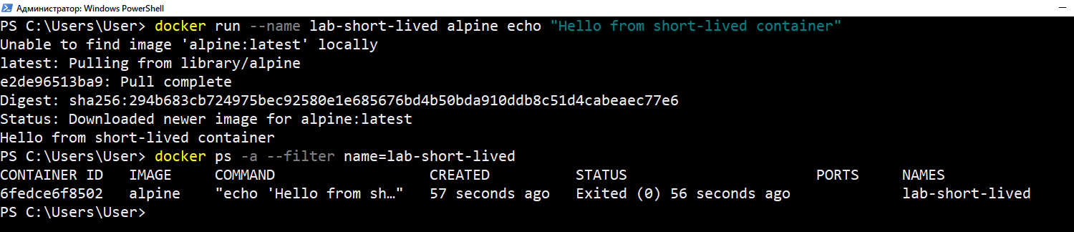
Это все про краткоживущий процесс

Теперь чистка.
